A/B Testing - Menu Layout Response Summary

* **Collated from Google Forms -** [**https://docs.google.com/forms/d/e/1FAIpQLSdBM7jmYRbrcMb2fIQpvlVuHG7auSCKEtAl4hzsk2rDPA8waw/viewform**](https://docs.google.com/forms/d/e/1FAIpQLSdBM7jmYRbrcMb2fIQpvlVuHG7auSCKEtAl4hzsk2rDPA8waw/viewform%20%20)
* **Questions represented as charts were required, others were not.**
* **Users were also presented with an .apk that showcased both menu styles if they preferred**

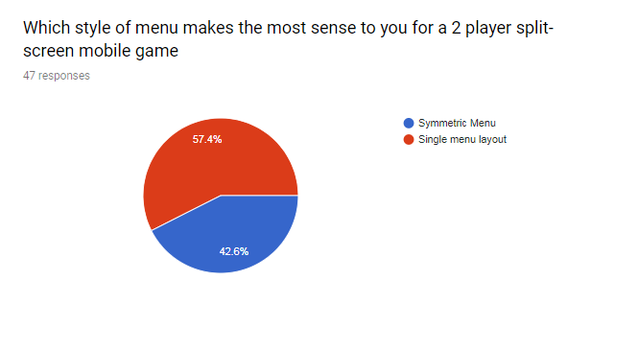

What stands out about both of the menu options

* I like the Single Menu layout as the overall splash screen for the game, but I think the symmetric menu makes most sense just as the game starts, kind of like a 'ready up' menu splash screen.
* I'm a little confused by the symmetric one, but the single menu layout clearly displays the play button
* The big play button on the single menu. The line across the middle and the text underneath it in the symmetrical version.
* Symmetric is too busy for a first glance. If the user is going to play a split screen game on a mobile device, the use case is either they've launched it in hand or on a surface. Transitioning to the splits screen game from a single menu makes more sense in the case of launching it from a hand to setting it down.
* Single Menu Layout catches the eye a lot quicker, as well as providing a much clearer visual of what the game is, rather than a half upside down mess. Assuming the person you are playing with isn't already on the other side of the screen.
* the single menu layout stands out as much clearer and easier to read. The symmetric menu layout stands out as supporting multiple players
* The buttons stand out the most.
* Symmetric - Seems easier to manage and the divide allows for clarity
* Single - Big play button
* The big play button seems more intuitive than 2 toggles
* Everything that's brown implies interaction.
* While the symmetric menu layout is an interesting option that guarantees interaction from both players, the single menu layout is more common and more intuitive.
* Symmetric - Both players can interact. Also prepares them for how the phone should be positioned.
* The play button on the single menu layout is much more intuitive, whilst the symmetrical layout is more user friendly for both players.
* The single menu has a clean visual, the symmetric menu has a nice mirror effect
* The Single Menu Layout seems much more stereotypical, so it would be easier to use in the sense that it would be what most casual players are used to, however, in terms of ease of use, the Symmetric Menu Layout is much more easy to use for two players as once, as it eliminates the need to constantly show the second person your phone, and instead can place it down on a surface for both to see.
* Single menu looks one player but is most pleasing on the eye.  
  Symmetric menu looks more confusing, heightening bounce rate for the game.
* More going on in the split screen one and defines how you're supposed to put the phone before the game has even started
* One has a "play" button, the other doesn't
* The word play stands out on the single menu layout. On the symmetric menu layout it's the tick at the bottom stands out the most
* Single Menu is much more concise and easy to experience
* The single is clean and simplistic, the symmetric seems over cluttered
* Much more simplistic and clearer to see immediately what is going on
* Single menu - Simple layout
* Single menu - Clear to operate

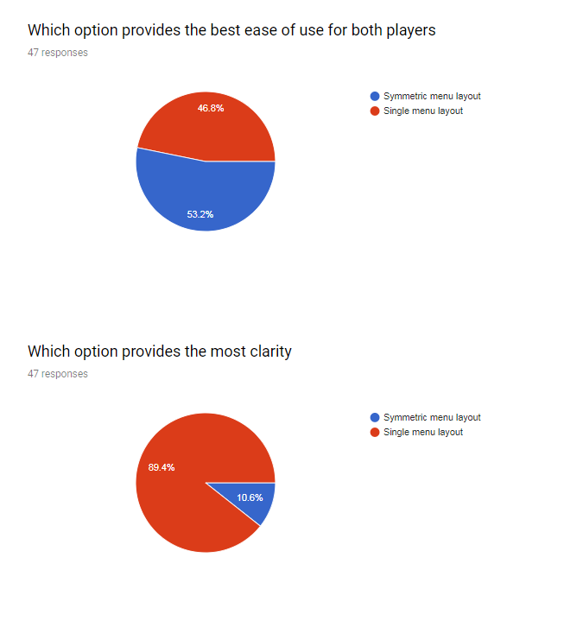



Other suggestions

* Don't do things upside down until the game starts.
* Adding a ready button for each player works well to support multiple players, I'd personally highlight what the ready button is doing (i.e. mark it as ready up or something).
* I think I prefer the single menu layout because it's not over crowded, but it completely depends on the game play.
* The symmetric menu seems more appropriate for two people on one device, but looks confusing for a single player. Single Menu is more 'normalized' based on what I've seen in other applications.
* A thinner, but brighter divider
* If the game wasnt turn based I would say the symmetrical layout is better but as it is not important for both player to be ready immediately the single button is better
* If you don't want to give up on the symmetric menu layout, you can use it at the beginning of the round so both players will choose when they are ready to start fighting against each other.
* It only makes sense to have a split screen layout menu if both players need to select something (e.g. choice of character). If only one choice needs to be made (e.g. game mode) then a single menu is clearer.
* "always a bigger fish" font is not that aesthetically pleasing but does the job. Maybe make it more bubble themed writing to go with the theme.
* I'm not sure what the game is about and what kind of options players have to select on the menu before playing, but it's usually easier for a single person to setup the settings I reckon
* As a suggestion, the single menu works best for easy of use, use of screen space and would flow well into a landing screen (settings etc) the other screen would work well as a ready screen, where both players have to press and hold before play.
* It's not that hard to understand a menu screen with one option, even when it's upside down.
* there is no reason to use the symmetric layout for a menu. only 1 player can and should interact with the menu. The other player playing is only interested when the game starts